The Arizona Assembly Business

General Assembly Meeting

Session #180
September 23rd, 2025
2nd and 4th Tuesday every month
Question and Answer Session at 6:00 pm
General Meeting at 7:15 pm
FreeConferenceCall HD
1-605-313-5140
passcode: 165223#



Biven's Decision
This meeting is private. Bearing false witness, misrepresentation, and posting inflammatory rhetoric in public forums is forbidden and shall be addressed in an appropriate manner. To eliminate all conflict and false allegations is there anyone in attendance at today's meeting that is a member or agent of any law enforcement agency of the federal, state county, city or township agencies, including United States Citizens? Is there any response to the Biven's Decision for the first time? Second Time? Third Time?
Being no response for the first, second or third time, I yield

Opening Statement
We are engaged in the practice of self-governance.
Disclaimer:
Everyone here is volunteering their precious time and skill. Each one is an American with rights and prerogatives equal to your own. They are doing this work out of mutual necessity, to restore the lawful American Government. Demands for service, temper tantrums, and misplaced anger are inappropriate. This country does not belong to its government. This country belongs to the people who live here. And you are one (1) of them.

Begin Recording
Welcome
Opening Statement - meeting decorum
Reading of the Biven's Decision
Opening Moment of Silence
Roll Call by County:
- Apache
- Cochise
- Coconino
- Gila
- Graham
- Greenlee
- La Paz
- Maricopa
- Mohave
- Navajo
- Pima
- Pinal
- Santa Cruz
- Yavapai
- Yuma

Reading and Approval to accept minutes of last meeting September 9th, 2025.

Treasurer's Report
Click above to see the Treasurer's report
﻿
~~~~~~~~~~~~~~~~~~~~~~~~~~~~~~~~~~~~~~~~~~~~~~~

ONGOING BUSINESS:
﻿

Committee Reports:
Notices Committee - Cheryl
Constitution Committee - Shirley
State Meet N Greet Committee - Frank or Diane
Litigation Committee - Nicole/ Dave
Out Reach Committee - Diane
Banking Committee - Cheryl
Forms Committee - Diane/ Gaye
For Review and Approval
Life Care Plan: Instructions
Life Care Plan: Designated Agent
Life Care Plan: Living Will
Life Care Plan: Mental Health
LIfe Care Plan: DNR
Coroners Committee - Bob or Nick
Militia - Jamey meeting Fridays at 6:30 pm 1-667-770-1449/ 595489#
Website Committee - John
Vetting Committee - Dennis/Cheryl
Jural Assembly - Dave -
Recording Secretary Handbook Committee - Diane/Polly
Ombudsmen Committee - Dave
Other Committees

﻿International Business Assembly - Cheryl
~~~~~~~~~~~~~~~~~~~~~~~~~~~~~~~~~~~~~~~~~~~~~~~~

﻿NEW BUSINESS:

- Update on Anna eviction.
- All Meeting replay links and/or minutes are to be sent to Dennis and John for website.
- State Meet n Greet - Pacific Seafood Buffet (Glendale) on October 11th - invite sent separately
- Current Protocols version 8.
- Protocols Committee meeting September 30th at 6:30 pm meetn.com/arizonaassembly
- Orientation Manual - need members
- Need new Scribe/Secretary to take minutes for State.
- No added moves or topics to the agenda unless it's an emergency.

Protocols for voting process: All votes go to county chairs in EMAIL form to be counted. On the State Call when the county is called the Chair reports (example) 15 yes, 2 no, 1 abstain. The County chairs will keep a detailed file of all the emails noting the name of the voter. Each county is responsible for Emailing their results to Dennis. Paper trail with name and vote. No votes counted if they are not emailed to county chair.

Need donations for Notices Committee and ongoing state assembly expenses. See links below for how to donate.

Move to adjourn meeting until October 14th, 2025
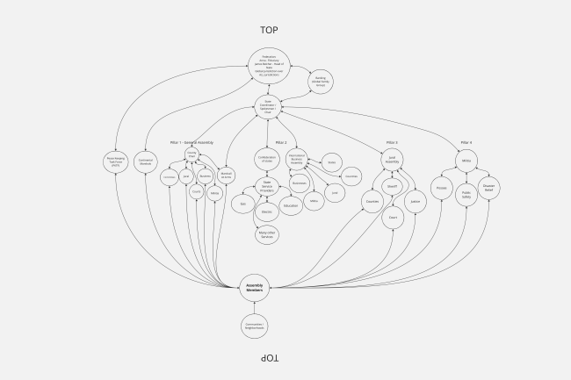

IMPORTANT DOCUMENTS FOR YOU TO READ
Click on the title of the document you wish to see

Magna Carta 1215

The Bill of Rights to the U.S. Constitution

Ordinance of 1787: The Northwest Territorial Government

18 Enumerated Powers of the Federal Government

Jural Assembly Handbook
Section 7 - Discipline
The Disruptors are all the nasty, pushy, I-am-important-my-issues-count-and-yours-don't, and the "I-have-a-problem-with-that," (whatever it is) on a constant basis folks. You all know who I am talking about. They always want to argue and split-hairs and find fault and gripe and blame and do very little to nothing themselves that is constructive, helpful or correct. They are like little cyclones causing chaos and impeding progress where ever they go, usually babbling about arcane, obscure points of law or grammar or similar ontological, semantic, or religious concerns. They are attention seekers who just won't take no for an answer or allow anyone else a fair shot at addressing other concerns. Sometimes these characters, especially the paid provocateurs, get together in pairs or small groups, and work together to keep everyone stymied. Take them aside and explain that people who disrupt the functioning of the Assembly or impede the conduct of business in State Jural Assembly meetings can and will be removed by the Marshal-at-Arms.

GIFTS AND DONATIONS
PayPal: https://www.paypal.com/paypalme/thearizonaassembly
Checks: Pay To: The Arizona Assembly
c/o Post Office Box 90924 White Mountain Lake, Arizona [85912]
Anna Von Reitz Cash App: $AnnaReize or Revolut.me/annariezinger

American Secured Party Creditor Confidentiality Notice:
This private email message, including any attachment(s), CC's, BCC's, or REPLIES are covered under this NOTICE and is limited to the sole use of the intended recipient and may contain Privileged and/or Confidential PRIVATE Information. Any and All Political, Private or Public Entities, Federal, State, or Local Corporate Government(s), Municipality(ies), International Organization(s), Corporation(s), Live Individual(s), person(s), agent(s), investigator(s), or informant(s), et al., and/or Third Party(ies) working in collusion by collecting, observing, monitoring, and/or analyzing My email(s), using any means of spying and/or data collection is PROHIBITED. Without My Exclusive WRITTEN Permission, all communications, herein, are PRIVATE.

Any omission(s) not specifically enumerated, herein, cannot be construed as permission by default. This notice prohibits Any and All Unauthorized Review, Use, Disclosure, or Distribution, verbally, or otherwise. With Explicit Reservation of All My Rights, Without Prejudice and Without Recourse to Me. Any omission does not constitute a waiver of any and/or ALL Intellectual Property Rights or Reserved Rights!

﻿Notice To Agents is Notice To Principals.
Notice To Principals is Notice To Agents.

