The Arizona Assembly Business

General Assembly Meeting

Session #177
August 12th, 2025
2nd and 4th Tuesday every month
Question and Answer Session at 6:00 pm
General Meeting at 7:15 pm
FreeConferenceCall HD
1-605-313-5140
passcode: 165223#



Biven's Decision
This meeting is private. Bearing false witness, misrepresentation, and posting inflammatory rhetoric in public forums is forbidden and shall be addressed in an appropriate manner. To eliminate all conflict and false allegations is there anyone in attendance at today's meeting that is a member or agent of any law enforcement agency of the federal, state county, city or township agencies, including United States Citizens? Is there any response to the Biven's Decision for the first time? Second Time? Third Time?
Being no response for the first, second or third time, I yield

Opening Statement
We are engaged in the practice of self-governance.
Disclaimer:
Everyone here is volunteering their precious time and skill. Each one is an American with rights and prerogatives equal to your own. They are doing this work out of mutual necessity, to restore the lawful American Government. Demands for service, temper tantrums, and misplaced anger are inappropriate. This country does not belong to its government. This country belongs to the people who live here. And you are one (1) of them.

Begin Recording
Welcome
Opening Statement
Reading of the Biven's Decision
Opening Moment of Silence
Roll Call by County:
- Apache
- Cochise
- Coconino
- Gila
- Graham
- Greenlee
- La Paz
- Maricopa
- Mohave
- Navajo
- Pima
- Pinal
- Santa Cruz
- Yavapai
- Yuma

Reading and Approval to accept minutes of last meeting July 22nd, 2025.

Treasurer's Report
Click above to see the Treasurer's report
﻿
~~~~~~~~~~~~~~~~~~~~~~~~~~~~~~~~~~~~~~~~~~~~~~~

ONGOING BUSINESS:
﻿

Committee Reports:
Notices Committee - Cheryl
Constitution Committee - Shirley
State Meet N Greet Committee - Frank or Diane
Litigation Committee -
Out Reach Committee - Diane
Banking Committee - Cheryl
Forms Committee - Gaye
Coroners Committee - Bob - need State Coroner
Militia - Jamey meeting July 25th 1-667-770-1449/ 595489#
Website Committee - John
Vetting committee - Dennis/Cheryl
Rat Watch Committee - Michelle/Stacey
Wellness Committee - Diane
Jural Assembly - Dave - seal
Recording Secretary Handbook Committee - Diane/Polly
Land Patent Committee
Ombudsmen Committee - Dave
Other Committees

﻿International Business Assembly - Cheryl
~~~~~~~~~~~~~~~~~~~~~~~~~~~~~~~~~~~~~~~~~~~~~~~~

﻿NEW BUSINESS:

- Update Orientation Manual - need committee members
- International Business Assembly Seal -Contact County chair with vote by Monday evening.
- Jural Assembly Seals - vote for 1 of 4 - send vote to County chair
- Coroner's Seal #1 #2 #3 - Send vote to County chair
- Stephanie (Ani) Plested - timeout
- Current Arizona Assembly Protocols version 8
- State Meet n Greet - Pacific Seafood Buffet (Glendale) vote for either September 27th or October 11th - send to County Coordinator. 1 PM casual, buffet style, no meeting just socializing.

Need donations for Notices Committee and ongoing state assembly expenses. see links below for how to donate.

Move to adjourn meeting until August 26th, 2025
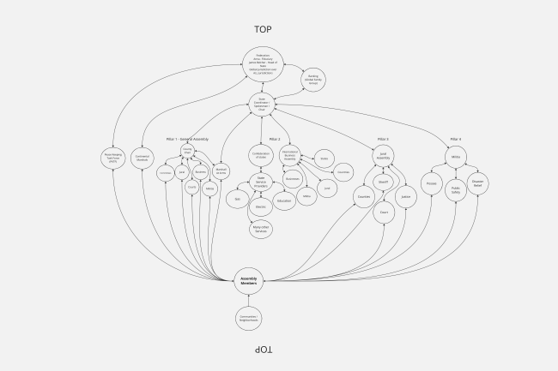

IMPORTANT DOCUMENTS FOR YOU TO READ
Click on the title of the document you wish to see

Magna Carta 1215

The Bill of Rights to the U.S. Constitution

Ordinance of 1787: The Northwest Territorial Government

18 Enumerated Powers of the Federal Government

GIFTS AND DONATIONS
PayPal: https://www.paypal.com/paypalme/thearizonaassembly
Checks: Pay To: The Arizona Assembly
c/o Post Office Box 90924 White Mountain Lake, Arizona [85912]
Anna Von Reitz Cash App: $AnnaReize or Revolut.me/annariezinger

